- Write a SELECT statement that returns four columns based on the InvoiceTotal column of the Invoices table.
  - Use the CAST function to return the first column as the decimal type with 2 digits to the right of the decimal point.
  - Use CAST to return the second column as the varchar type.
  - Use the CONVERT function to return the third column as the same data type as the first column.
  - Use CONVERT to return the fourth column as a varchar, using style 1
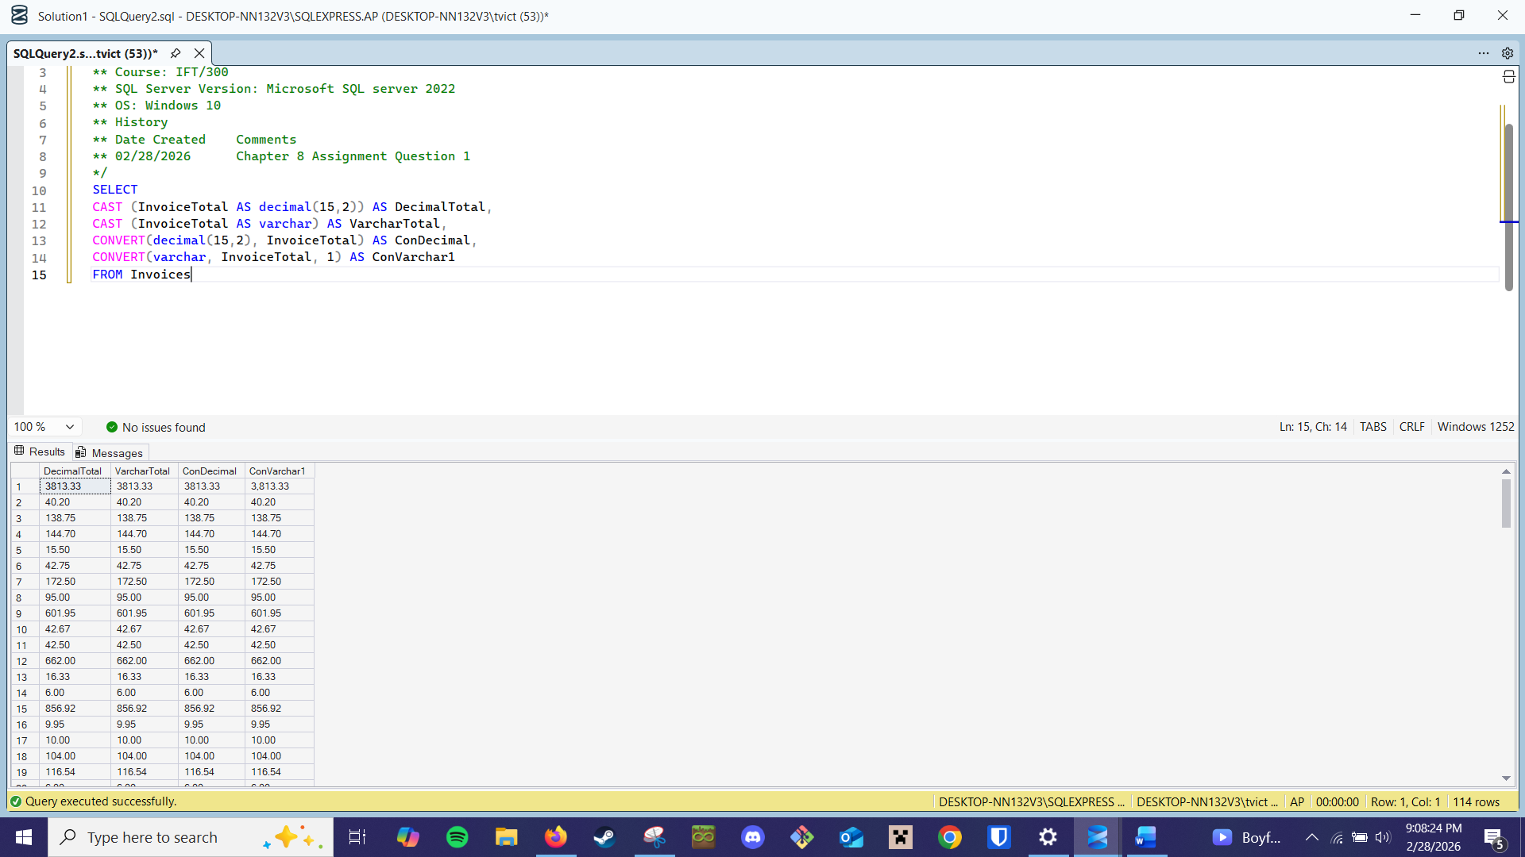
- Write a SELECT statement that returns three columns based on the InvoiceDate column of the Invoices table.
  - Use the CAST function to return the first column as the varchar type
  - Use the TRY_CONVERT function to return the second and third columns as the varchar type, using style 1 and style 10 respectively.
